Trishla Chaurasia

Report for Splicing:

I have used the idea described in the following paper for splicing detection:

<https://hal-upec-upem.archives-ouvertes.fr/hal-01510075/document>

Where the authors talk about the fact that different images have different noise characteristics, according to the camera and lighting conditions during the image acquisition. The proposed method automatically detects image splicing in raw images by highlighting local noise inconsistencies within a quadtree scan of the image. The image noise is modelized by both Gaussian and Poisson noise components.

In order to implement the estimation of noise inconsistencies, I have used IVHC.

(<https://github.com/meisamrf/ivhc-estimator/blob/master/README.md>).

IVHC is a model to estimate Gaussian, signal-dependent, and processed noise in image and video signals. The estimation is based on the classification of intensity-variances of image patches in order to find homogeneous regions that best represent the noise.

So, to implement this , I have broken the images into patches and ran IVHC for all the patches. IVHC outputs sigma p and sigma o.

Sigma p: It is variance of noise in the Y channel at highest rank noise representative cluster. Under signal-independent noise, sigma_p estimates the standard deviation of noise. Under signal-dependent noise, sigma_p is likely to be the peak of the noise.

Sigma_o = sigma_p*gamma, where gamma is the degree of processing.

I have then collected the sigma p and sigma o for all the patches and ran Isolation Forest from sklearn.ensemble to predict the outliers .The outliers would be the regions where splicing is done .

Results:

 : 

Spliced image :



Output result :

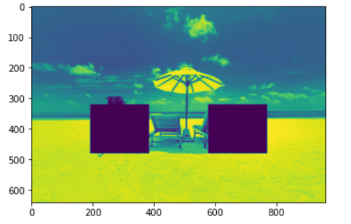

2.

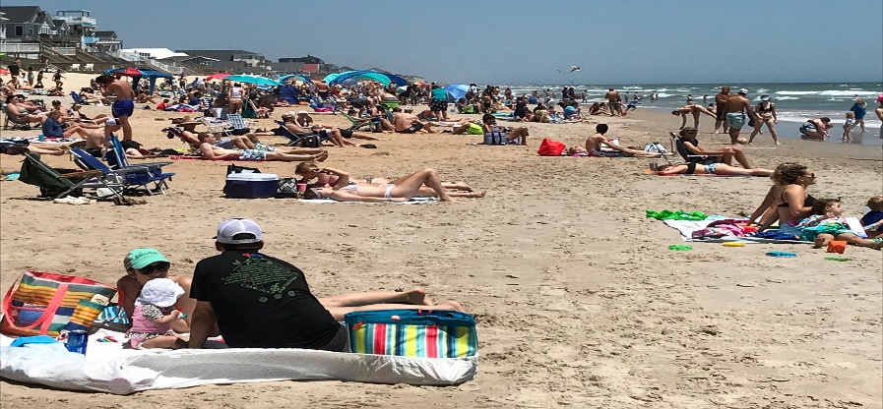



Spliced Image:

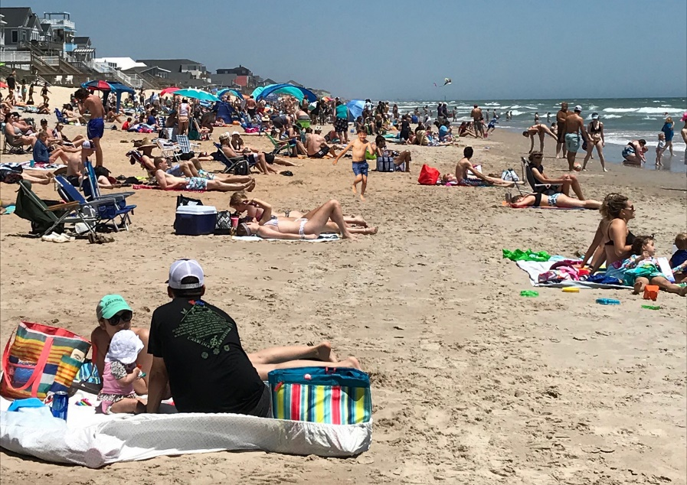

Output Result :

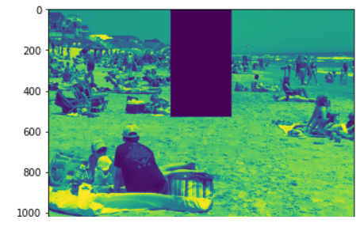

It is working for some but for some images it is also giving false positives.